1. Which are the top three variables in your model which contribute most towards the probability of a lead getting converted?

Answer: The top three variables that contribute most towards the probability of a lead getting converted are those variables that have positive coefficients

1. Lead Origin_Lead Add Form
2. What is your current occupation_Working Professional
3. Last Notable Activity_Had a Phone Conversation

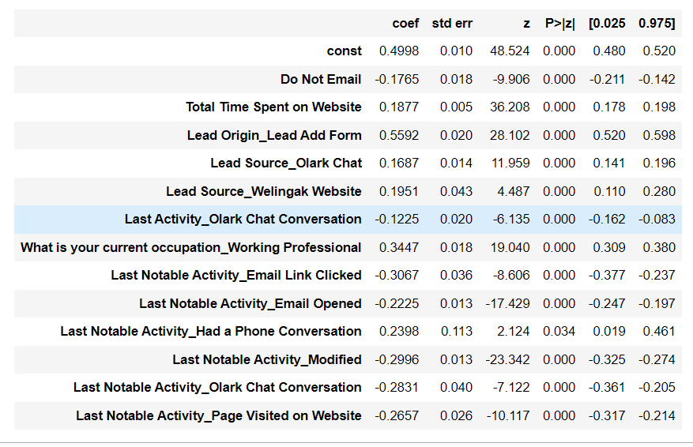

1. What are the top 3 categorical/dummy variables in the model which should be focused the most on in order to increase the probability of lead conversion?

Answer : As per the above diagram the top 3 categorical dummy variables are also:

1. Lead Origin_Lead Add Form

2.What is your current occupation_Working Professional

3. Last Notable Activity_Had a Phone Conversation

1. X Education has a period of 2 months every year during which they hire some interns. The sales team, in particular, has around 10 interns allotted to them. So during this phase, they wish to make the lead conversion more aggressive. So they want almost all of the potential leads (i.e. the customers who have been predicted as 1 by the model) to be converted and hence, want to make phone calls to as much of such people as possible. Suggest a good strategy they should employ at this stage.

Answer: We can come up with a good strategy by taking sensitivity and specificity into consideration

In our model **sensitivity** can be defined as the ratio of the total number of actual conversions correctly predicted to the total number of actual conversions.

And **specificity** can be defined as the ratio of total no of actual non-conversions correctly predicted to the total number of actual non-conversions.

We can attain different values of sensitivity and specificity for the same model by just varying the cut-off value.

The cut-off value for our model is given below

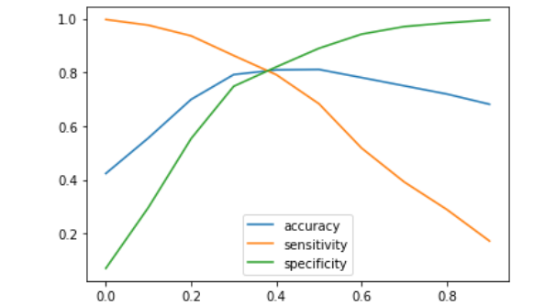From the diagram we can observe that when the cut-off is very low the sensitivity is very high and the specificity is very low and similarly vice versa when the cut-off is very high.

If we **reduce the cut-off** value our sensitivity will be high meaning that it will wrongly classify some non-conversion cases as conversion cases. But this would not hamper the business of the X education. Since the company has more man-power they can make the most conversions by choosing a lower cut-offf value, higher sensitivity and not missing out on any potential leads.

1. Similarly, at times, the company reaches its target for a quarter before the deadline. During this time, the company wants the sales team to focus on some new work as well. So during this time, the company’s aim is to not make phone calls unless it’s extremely necessary, i.e. they want to minimize the rate of useless phone calls. Suggest a strategy they should employ at this stage.

Answer: Since the company has reached its target for the quarter and they do not Want to focus on unnecessary calls, we can use the similar logic as in the previous solution by now considering a **high cut-off** value , high specificity which ensures that almost al leads who are non-conversions are rightly classified so that the company need not make unnecessary calls